Week 4

Practice problem 4.1
PP4-1: Suppose event A occurs 1050 times, event B occurs 720 times, event C occurs 120 times and event D occurs 1110 times. Calculate the relative frequency of each event and report the probabilities of each event.
a. P(A) = ___
b. P(B) = ___
c. P(C) = ___
d. P(D) = ___

Practice problem 4.12
PP4.12(a): Convert the following contingency table to a probability matrix to solve the equations given.
(a) P(A) = ___ (c) P(A⋂E) = ___

 | D | E | Total
A | 16 | 8 | 24
B | 10 | 6 | 16
C | 8 | 2 | 10
Total | 34 | 16 | 50

Practice problem 4.8
PP4.8: A white goods manufacturer is sourcing parts for its air conditioning units. Management are currently putting together a timeline for the next stages of manufacturing. To do so they consider that one set of parts relating to the motor are coming from Germany and one set of parts relating to the casing will come from the United States. Past experience suggests that there is an 8% probability that the German parts will arrive late due to disruptions in shipping. The probability of parts arriving late from the United States is deemed to be 5%.
(a) What is the probability that parts from Germany will not be delayed?
(b) What is the probability that parts from the United States will not be delayed?

Practice problem 4.10
PP4-10: A government department investigating the issues of tax avoidance and evasion determines that the following outcomes have occurred in a random sample of 400 cases.
Tax return assessment Returns
Not filed 80
Filed with no evasion to be investigated 260
Filed with minor level of possible evasion to be investigated 40
Filed with major level of possible evasion to be investigated 20

(a). What is the probability that a tax return will be filed? Show how considering the complement of this event provides at least two methods of answering this question.

(b). Using the information provided, explain why the event of some form of evasion requiring further investigation occurring among those who do file an assessment is not an elementary event.

Practice problem 4.3
PP4.3: A company advertising used cars for sales classifies vehicles based on the shape of the vehicle into one of eight mutually exclusive categories. What is the probability that a randomly selected vehicle will be: (a) a ute?

Body type No. of vehicle for sale
4WD/SUV 8330
Coupe 1190
Hatchback 17850
People mover 9520
Sedan 47600
Ute 5950
Van 4760
Wagon 23800

Practice problem 4.16
PP4.16: Use the values in the following matrix to solve the equations given.
a. P(A⋃ D) c. P(D⋃ E)
 | D | E | F
A | 5 | 8 | 12
B | 10 | 6 | 4
C | 8 | 2 | 5

Review Problem 4.3
RP4.3: The following probability matrix contains a breakdown of the age and gender of general practitioners working in Australia.
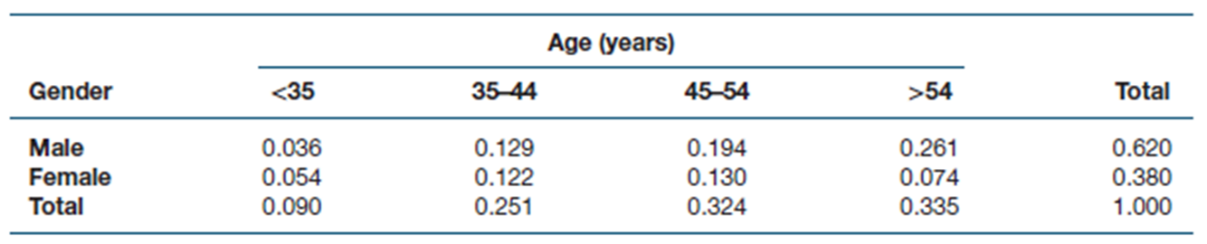
What is the probability that one randomly selected general practitioner:
(a) is 35–44 years old
(c) is male or is 35–44 years old
(d) is less than 35 years old or more than 54 years old

Practice problem 4.20
PP4.20: A survey conducted by Roy Morgan Research asked 1116 Australians to nominate health issues they consider important. Sixty per cent of respondents nominated cancer as an important health issue, and only 29% mentioned heart disease. Assume that these percentages are true for the population of Australia and that 25% of all respondents mentioned both cancer and heart disease as important health issues.
(a) What is the probability that a randomly selected Australian nominates either cancer, heart disease or both as important health issues?

(d) Construct a probability matrix for this problem and indicate the locations of your answers to parts (a), (b) and (c) on the matrix.

Practice problem 4.28(a)
PP4.28 (a): Use the values in the following contingency table to solve the equations given.
(a) P(G|A) (c) P(C|E)
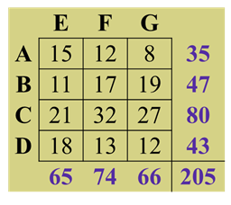

Activity 4.1
Activity 4.1: The proprietor of an office building wants to know the preferred air temperature inside the building by people who work in there. He conducts a survey of 120 randomly selected office workers as to whether they are more comfortable in 24⁰C or in 20⁰C. Based on his survey he discovers that 70 workers start work early and leave early, and among those 30 prefer 24⁰C. Of the remaining workers who start late and work till late, 23 have said their preferred temperature is 20⁰C. Construct the contingency table and determine the probability that a randomly selected worker starts early given that his or her preferred temperature is 20⁰C.

Practice problem 4.30
PP4.30: Consider the following results of a survey asking, ‘Have you visited a museum in the last 12 months?' and 'Do you have any children less than 10 years of age?’ Is the variable ‘Museum visitor’ independent of the variable ‘Children under 10’? Why or why not?
Visited museum in last year
Children under 10 Yes No Total
Yes 160 80 240
No 40 120 160
Total 200 200 400

Practice problem 4.22
PP4.22: Given P(A) = .40, P(B) = . 25, P(C) = .35, P(B | A) = .25 and P(A | C) = .80, solve the following. (a) P(A∩ B) (c) P(A ∩ C)

Review problem 4.6
RP4.6: A large bank reports that 30% of families have a MasterCard, 20% have an American Express card, and 25% have a Visa card. Eight per cent of families have both a MasterCard and an American Express card. Twelve per cent have both a Visa card and a MasterCard. Six per cent have both an American Express card and a Visa card.
(a) What is the probability of selecting a family that has either a Visa card or an American Express card?
(b) If a family has a MasterCard, what is the probability that it also has a Visa card?
(c) If a family has a Visa card, what is the probability that it also has a MasterCard?
(d) Is possession of a Visa card independent of possession of a MasterCard? Why or why not?
(e) Is possession of an American Express card mutually exclusive of possession of a Visa card?

Activity 4.2
Activity 4.2: The Venn diagram below shows a total of 268 students in science in a high school. Among them A represents 92 students studying physics, B represents 98 students studying chemistry and C represents 110 students studying mathematics. Twelve students are studying both physics and chemistry, 10 students are studying both chemistry and mathematics and 14 students are studying both physics and mathematics. How many students are studying all three subjects?
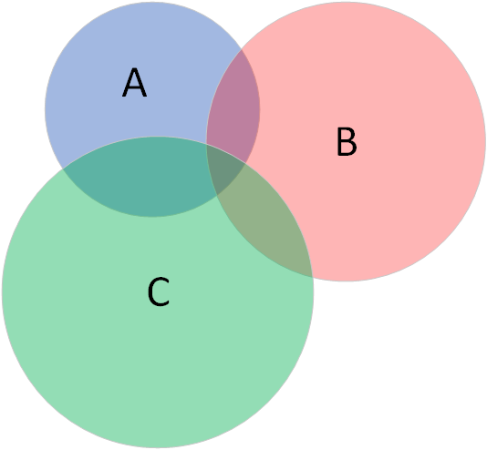

Activity 4.3
In Perth 60% of the licensed drivers are 30 years of age or older. Of all drivers of 30 or older, 4 % had a traffic violation in the last 12 months. Of all drivers under the age of 30, 10% had a traffic violation in the last 12 months. If a driver has just been charged with a traffic violation, what is the probability that the driver is under 30 years of age?

Activity 4.4
Activity 4.4: Two manufacturers supply blankets to emergency relief organisations. Manufacturer A supplies 3,000 blankets, of which 4 % are irregular in workmanship. Manufacturer B supplies 2,400 blankets, of which 7 % are irregular in workmanship. Given that a randomly selected blanket has irregular workmanship, find the probability that it is supplied by manufacturer A.

Activity 4.5
Activity 4.5: If there are nine starters in a race, in how many different ways can first, second, and third prizes be awarded?

Activity 4.6
Activity 4.6: The Transport Department is investigating whether or not to use three letters and three digits on number plates. How many different number plates are available under this system?

Activity 4.7
Activity 4.7: A particular lottery awards the first division prize to any ticket which contains all six numbers (on one line of the ticket) selected at the random draw. If there are 45 numbers in total, how many different ways can six numbers be selected from among the 45?

Activity 4.8
Activity 4.8: The High Court of Australia has 7 judges currently led by Chief Justice Susan Mary Kiefel AC. If on any day three judges are required in Court 1 and two judges are required in Court 2, in how many ways the judges for the two courts can be selected?

Activity 4.9
Activity 4.9: An environmental sub-committee comprising 3 members and an infrastructure sub-committee comprising 2 members are to be constituted from a committee of 12 members. In how many ways can these two sub-committees be selected from among the 12 committee members provided no member can be at two sub-committees at the same time?

